36.61: a) For the maxima to occur for  slits, the sum of all the phase differences between the slits must add to zero (the phasor diagram closes on itself). This requires that, adding up all the relative phase shifts, 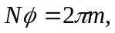 for some integer . Therefore 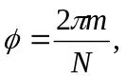 for not an integer multiple of 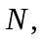 which would give a maximum.
b) The sum of phase shifts 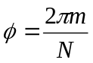 brings you full circle back to the maximum, so only the 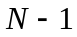 previous phases yield minima between each pair of principal maxima.

